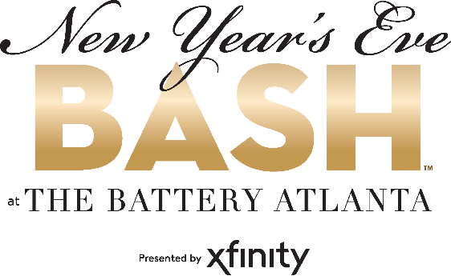
For more information:
Diana Torres
BRAVE Public Relations
404.233.3993
dtorres@emailbrave.com
FOR IMMEDIATE RELEASE

New Year’s Eve Bash at The Battery Atlanta offers multiple festivities to ring in 2022
Cobb County lifestyle destination’s open-air campus plans New Year’s Eve events and outdoor entertainment

ATLANTA (Dec. 13, 2021) – Say goodbye to 2021 and hello to 2022 at the annual New Year’s Eve Bash at The Battery Atlanta presented by Xfinity. The community is invited to ring in the new year at multiple celebratory events happening throughout the Southeast’s premier entertainment destination. Select restaurant and bars – including CRÚ Food & Wine Bar, Live! at the Battery Atlanta and Park Bench – are hosting advanced reservation events.

The Early Inning celebrations will begin at 6 p.m. with music from The Lucky Band – named ‘THE face of kindie music’ by The Washington Post. Following the band’s performance, children can join in for a countdown to an inflatable balloon drop at 8 p.m.

Late Innings begin at 9 p.m. as emcee Mark Owens welcomes 12 South Band, as festivities culminate with an aerial firework and confetti display over Truist Park at midnight. Parking in the Red, Green, Yellow, Purple, Silver, Delta, 900 and 1100 Decks and Surface Lots will be free for this event beginning at 6 p.m. on December 31, 2021 and will continue until noon on January 1, 2022. Please note, the Orange Deck is not included.

An up-to-date list of restaurant and retailer happenings is available on the website. Details and hours of operation are subject to change.

New Year’s Eve Events:
New Year’s Eve Celebration Dinner at CRÚ Food & Wine Bar
Friday, Dec. 31 from 5 p.m.-midnight
The chef-driven restaurant is dishing out a prix-fixe gala dinner menu complete with four courses ($75). Space is limited so reservations are encouraged. Learn more here.

NYE Live! 2021 at Live! at the Battery Atlanta
Friday, Dec. 31 at 8 p.m.
From the balloon drop to the bowl games, your weekend is covered! Live! is offering a variety of packages to celebrate the arrival of the New Year with host Blake Eason. Grab your tickets for a fun night culminating with a balloon drop and a midnight champagne toast! Learn more here.

New Year's Eve Party at Park Bench
Friday, Dec. 31 at 6 p.m.
The well-known live music venue invites guests out for an early Piano show at 6 p.m., the Main Event with DJ Tron kicks off at 9 p.m. with a late night full of pop, dance and country rock party hits! A limited number of advanced tickets are available and include admission, party favors and a complimentary midnight champagne toast. Select VIP tables with bottle service available. Learn more here.

# # #
About The Battery Atlanta
The Battery Atlanta, a 2 million square-foot mixed-use development, located at the intersection of I-75 and I-285, offers an unmatched mix of boutique shopping, market-exclusive entertainment experiences, chef-driven restaurants, the Omni and Aloft Hotels, The Coca-Cola Roxy and 531 residences. The complex includes offices One Ballpark Center, Comcast’s regional headquarters; Two Ballpark Center, home to SPACES; Three Ballpark Center, which will serve as Papa John’s global headquarters and TK Elevator’s North American headquarters; and Four Ballpark Center, home to DCO Commercial Floors. Powered by Comcast’s all-fiber network and delivering multi-terabit capabilities, The Battery Atlanta has the highest-capacity network serving any mixed-use development in the nation. For more information on The Battery Atlanta please visit batteryatl.com or connect on Facebook, Instagram and Twitter.

